COM6523 Software Reengineering Group Project Report

Group ID | PG_05
Group Repository | https://github.com/TUOS-COM-Reengineering-2026/group-project-pg_05
Selected Open-Source System | aio-libs/yarl
Original Repository | https://github.com/aio-libs/yarl
Snapshot Commit Used | e25e8d23e6912db52a23513ef1f6a17f889751ef
Main Reengineering Target | URL.join() in yarl/_url.py

Member | Student ID | Main Responsibilities
 |  | Project setup, repository preparation, local environment setup, baseline regression testing, and GitHub workflow management.
 |  | Current system understanding, module inventory, public API analysis, and baseline structure analysis.
 |  | Upstream repository evolution analysis, commit history analysis, LOC-over-time analysis, and chart generation.
 |  | Code smell analysis, reengineering target selection, restructuring requirements, and risk analysis.
 |  | Regression test design, URL.join() refactoring, private module restructuring, local quality-check script, and before/after evaluation.

- Introduction
This project focuses on the reengineering of aio-libs/yarl, an open-source Python library for URL parsing, construction, normalisation, quoting, and manipulation. The central abstraction of the system is the URL class, which provides users with a structured and convenient way to create, inspect, modify, and combine URLs. Because URL handling is a common requirement in web frameworks, HTTP clients, asynchronous networking libraries, and other internet-facing software, the correctness and maintainability of this library are important.
yarl was selected as the subject system because it satisfies the practical requirements of the reengineering project. It is an active open-source project with a substantial version history, a clear repository structure, a documented purpose, and a runnable automated test suite. The system also has enough source code and test code to support meaningful program comprehension and restructuring work. At the analysed snapshot, the upstream repository contained 1927 commits, and the project had grown to 9171 total lines across selected source and test files. This made it suitable for repository history analysis, static analysis, regression testing, and before/after evaluation.
The snapshot used as the basis of this project was commit e25e8d23e6912db52a23513ef1f6a17f889751ef from the original aio-libs/yarl repository. Following the coursework requirements, this snapshot was first imported into the group repository before any reengineering work was started. A local Python environment was then configured, and the original regression test suite was executed to establish a baseline. The baseline local test result was 1115 passed, 103 skipped, and 2 xfailed, showing that the imported system was runnable and suitable for controlled reengineering.
The overall aim of the project was not to rewrite the whole library, but to identify a focused, evidence-based reengineering opportunity and improve it without changing the public behaviour of the system. Initial static analysis showed that yarl/_url.py is the central and most complex module. Within this module, URL.join() was selected as the main restructuring target because it had non-trivial cyclomatic complexity, was part of the public behaviour of the URL class, and had previously attracted refactoring attention in the upstream project history.
The reengineering work therefore focused on improving the maintainability and modularity of URL.join(). Focused regression tests were added before refactoring, the method was simplified through helper extraction, and join-specific helper logic was later moved into a new private module, yarl/_join.py. The final local verification showed that all regression tests still passed, while the complexity of URL.join() was reduced from C (17) to B (8).

- Understanding the System

  - System Purpose and High-Level Architecture
aio-libs/yarl is a Python library for working with URLs. Its main purpose is to provide a structured, reliable, and convenient representation of URLs, rather than forcing users to manipulate URL strings manually. The central abstraction of the system is the URL class. Through this class, users can construct URLs, inspect individual components, modify paths or query strings, normalise URL parts, quote and unquote unsafe characters, and join base URLs with relative URLs.
At a high level, the system is organised around a small number of focused modules. The most important module is yarl/_url.py, which contains the core URL class and most of the public URL manipulation behaviour. Other modules support lower-level responsibilities, such as URL parsing, path normalisation, query string handling, and quoting logic. The project also includes both pure Python and Cython-based quoting implementations, showing that performance is a consideration in some parts of the system.
The system can therefore be understood as a compact but mature library with a central public API and several supporting internal utilities. Its design is relatively simple from a user perspective because most interaction happens through the URL object. However, internally, the logic is more complex because URL handling involves many edge cases, including absolute URLs, relative paths, encoded characters, query strings, fragments, authority components, and normalisation rules.
Table 1 Main modules and responsibilities in yarl
Module | Main Responsibility | Reengineering Relevance
yarl/_url.py | Defines the core URL class and most URL transformation methods | Central and complex module; main reengineering target located here
yarl/_parse.py | Provides URL parsing and splitting logic | Important for correctness but lower-level
yarl/_path.py | Handles path normalisation and path segment processing | Used by URL path and join behaviour
yarl/_query.py | Handles query string and query variable conversion | Supports query-related URL methods
yarl/_quoting_py.py | Pure Python quoting and unquoting logic | Important fallback implementation
yarl/_quoting_c.pyx | Cython acceleration for quoting logic | Performance-related implementation
yarl/_join.py | Private module added during restructuring to hold URL join helper logic | Result of the system-level restructuring

This modular structure shows that yarl already separates some responsibilities, but the baseline analysis also showed that yarl/_url.py still carried a large amount of responsibility. This made it a natural focus for deeper program comprehension.
  - Public API and Regression Risk
The public API of yarl is centred on the URL class. This makes the library easy to use, but it also means that changes to the URL class can affect many behaviours. Refactoring public-facing methods therefore carries higher risk than refactoring isolated private helper functions.
The public API inventory showed that the most important exported object is URL. Other exported names include query-related typing aliases and cache utility functions. Since URL is the main public abstraction, the project treated behaviour preservation as a key requirement. The aim was not to redesign the API or introduce a new feature, but to improve internal maintainability while keeping existing public behaviour unchanged.
This was especially important for URL.join(), which combines a base URL with another URL. URL joining is a behaviour that users may rely on when resolving relative links, constructing HTTP requests, or handling web paths. A small behavioural change in this method could cause subtle bugs in downstream projects. For that reason, regression tests were considered essential before any restructuring work.

  - Baseline Regression Testing
Before any reengineering work was carried out, the original test suite was executed locally to establish a behavioural baseline. The result was:
1115 passed, 103 skipped, 2 xfailed.
This result showed that the imported snapshot was runnable and that the main test suite was functioning in the local environment. The skipped tests were mainly related to optional dependencies, benchmark requirements, or extension availability. They did not indicate that the core library functionality was failing. The two xfailed tests were expected failures already recognised by the test configuration.
The test inventory also showed that yarl has a substantial test suite. This is important for reengineering because a strong regression test base makes it safer to perform refactoring. In this project, the existing tests were used as a general safety net, while additional focused tests were later added for the selected reengineering target.
A limitation was that GitHub Actions could not be used for automatic remote validation because the course organisation had reached its GitHub Actions quota. The course announcement stated that students should run automated tests, regression checks, and coverage reports locally. Therefore, all testing and metric collection in this project was performed locally, and the outputs were committed as evidence.
  - Baseline Size and Static Metrics
The baseline LOC analysis showed that the analysed version of yarl contained 9171 total lines across the selected source and test files. Of these, 2764 were source lines and 6407 were test lines. The fact that the test code was larger than the source code suggests that the project has a relatively strong testing culture and that regression testing is an appropriate strategy for this reengineering task.
The complexity analysis identified yarl/_url.py as the most significant module for further inspection. This was expected because the module contains the URL class and many methods related to URL construction, transformation, and inspection. The highest complexity findings in the baseline report included:
URL.build: E (38)
encode_url: C (20)
URL._make_child: C (17)
URL.join: C (17)
_encode_host: C (15)
These results indicate that several parts of the core URL logic are non-trivial. URL.build() had the highest complexity, but it is also a broad construction method with many parameters and behaviours. Refactoring it would carry a higher risk and would require a wider test design. In contrast, URL.join() had a high enough complexity to justify attention, but its behaviour was narrower and easier to cover with focused regression tests. For this reason, URL.join() became a stronger candidate for the restructuring phase.
The maintainability analysis also supported the conclusion that yarl/_url.py was a key area of concern. While several supporting modules had high maintainability ratings, the central URL module was more complex and carried more responsibility. This is a common pattern in libraries where a central class accumulates behaviour over time. The issue is not necessarily that the module is poorly written, but that its central role makes it harder to maintain safely as the project grows.

  - Evolution of the System
The repository history analysis showed that the upstream aio-libs/yarl project had 1927 commits at the analysed snapshot. This confirms that the system has a substantial development history and is suitable for version repository analysis. The LOC-over-time analysis showed that the project grew from around 1205 total lines in early versions to around 9171 total lines at the analysed HEAD. This growth reflects the increasing maturity of the library.
The LOC chart shows that both source code and test code increased over time. A particularly important observation is that the test lines eventually became larger than the source lines. This suggests that the project evolved from a smaller utility into a more mature library with extensive regression coverage. For a reengineering project, this is valuable because the existing test suite can be used to detect accidental behavioural changes.
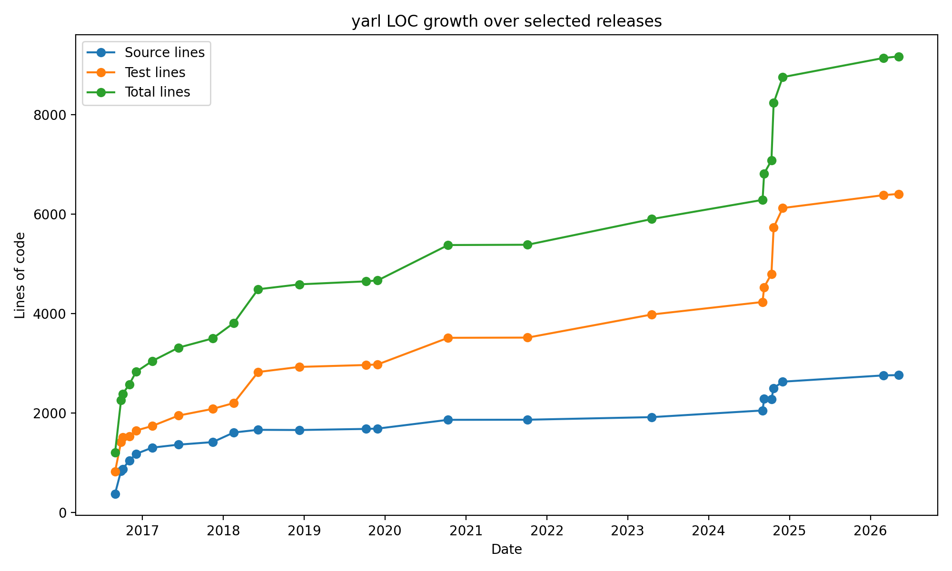
Figure 1 LOC growth over selected yarl releases
The commits-by-month chart provides another view of the project’s evolution. Periods with higher commit activity suggest phases of active development, maintenance, or restructuring. These activity patterns are useful because they help identify when the project changed rapidly and when it stabilised. In the report, this chart can be used to support the argument that yarl has gone through multiple phases of growth and maintenance rather than being a static codebase.
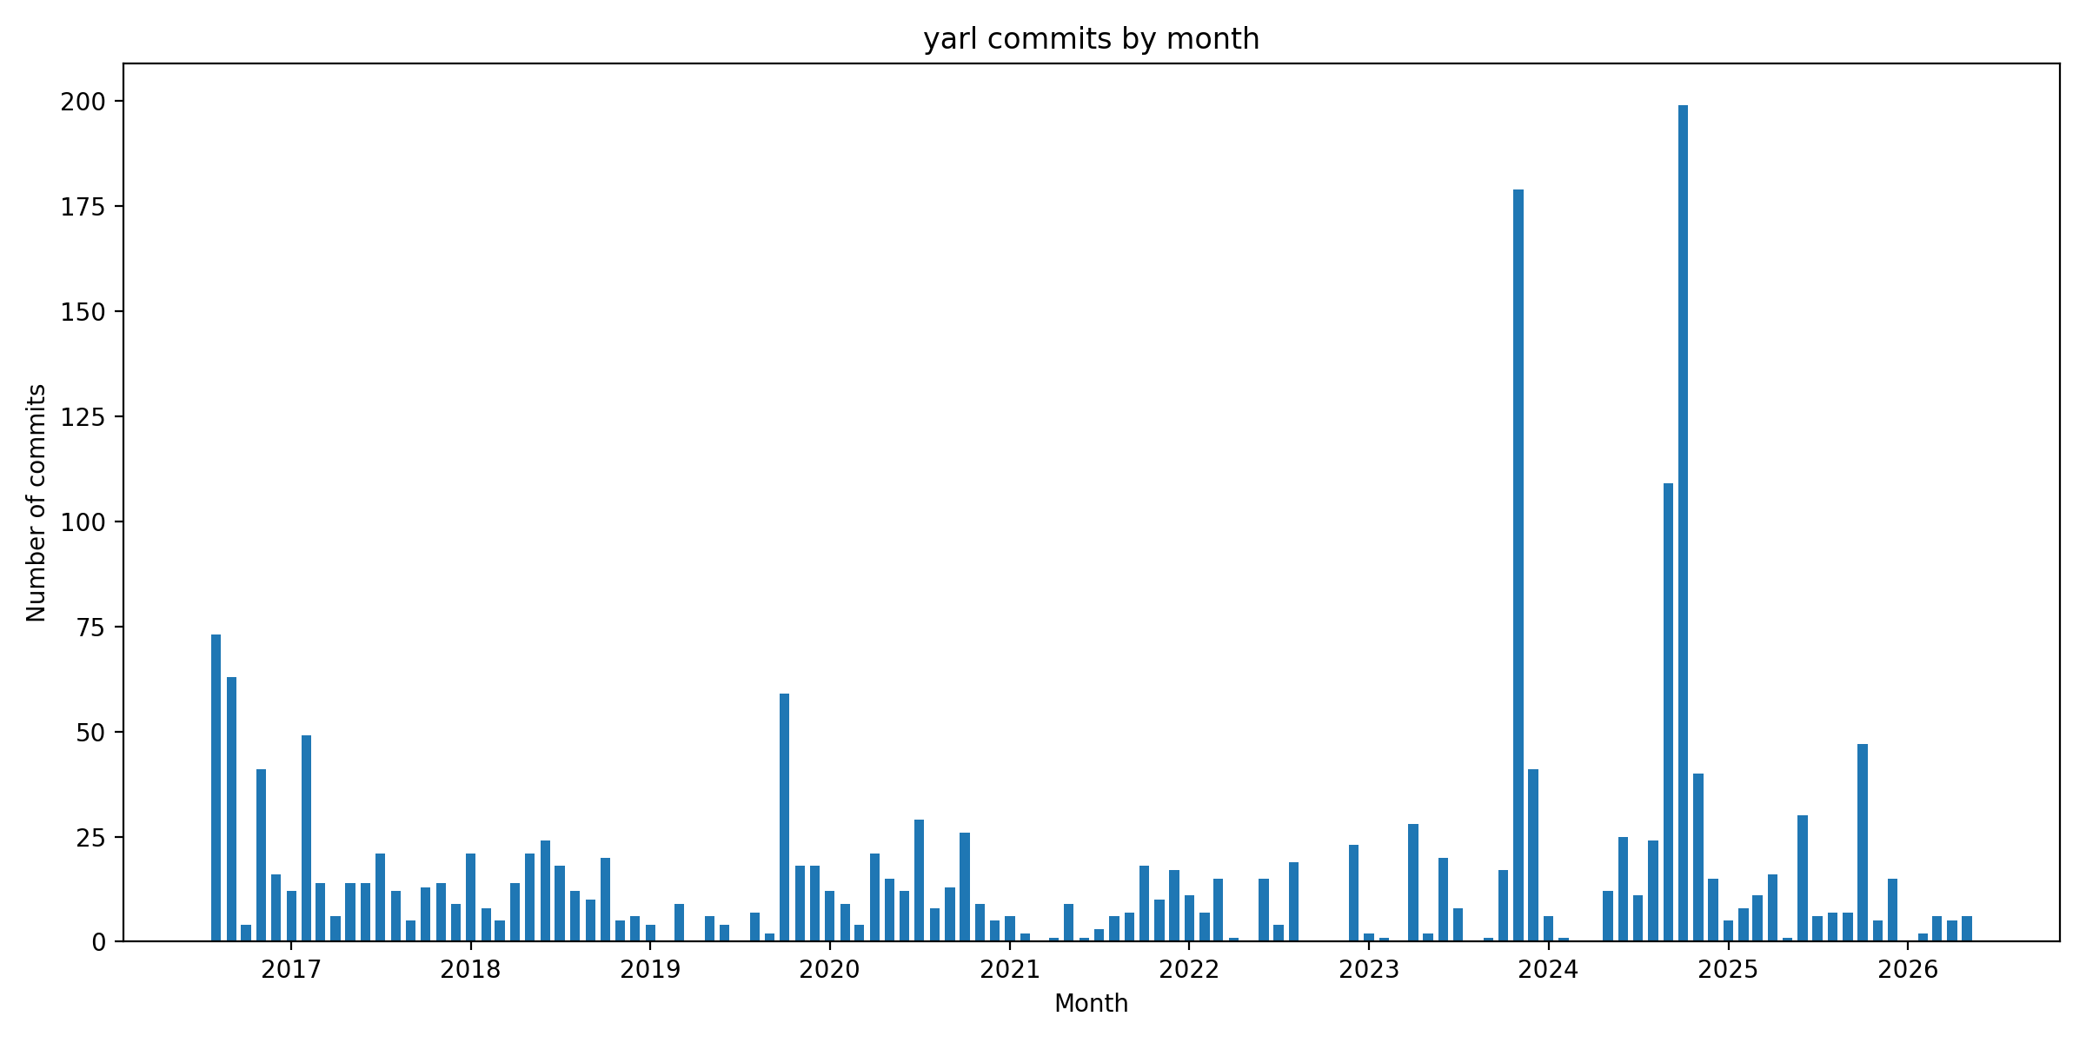
Figure 2 Commit activity by month in the upstream yarl repository

Overall, the evolution analysis suggests that yarl is not a small one-off project. It has grown steadily, accumulated a large regression test suite, and undergone repeated maintenance. This makes it a suitable subject for reengineering because there is enough history and structure to analyse, but the system is still compact enough for a focused restructuring task.

  - Original Developers’ Reengineering Efforts
The keyword-based search of upstream commit history identified several commits related to refactoring, cleanup, simplification, and restructuring. These included commits such as:
- “Refactor URL.join to avoid intermediate dict”
- “Remove some intermediate variable”
- “Small cleanup to URL.join”
- “Additional small cleanups”
These commits suggest that the original developers had already recognised maintainability concerns in parts of the URL joining and transformation logic. This is important because it shows that the selected reengineering area was not arbitrary. The project history itself indicates that URL.join() and related URL transformation logic have previously required cleanup and refinement.
However, the presence of past refactoring does not mean that no further reengineering opportunities remain. The baseline complexity report still showed URL.join() as C (17), indicating that the method remained relatively complex. This made it a reasonable target for a small, evidence-based refactoring.
The original developers’ refactoring efforts also influenced the project strategy. Instead of attempting a risky redesign, the group followed the same conservative style: improve internal structure while preserving public behaviour. This approach is appropriate for a widely used library because compatibility is more important than aggressive redesign.

  - Remaining Code Smells and Maintainability Concerns
The main code smell identified in the baseline snapshot was concentrated complexity in yarl/_url.py. This module is central to the system and contains many responsibilities related to URL creation, parsing, modification, normalisation, joining, and component access. While it is understandable that a URL class would contain many behaviours, the concentration of logic in one module increases maintenance difficulty.
The selected method, URL.join(), showed a more specific form of this problem. It combined several responsibilities inside one method:
- checking the type of the input URL
- selecting or preserving the scheme
- handling absolute URL replacement
- handling network-path references
- resolving relative paths
- selecting the correct query string
- selecting the correct fragment
These responsibilities are related, but they are conceptually different. Keeping them all inside one method makes the method harder to read and harder to modify safely. It also makes it more difficult to understand which part of the method handles which URL component. This is a typical Extract Method opportunity.
Another concern is that URL.join() is public-facing behaviour. This means that even a small internal change could break user expectations. Therefore, the smell could not be addressed by simply rewriting the method. It required a controlled approach: first add focused regression tests, then refactor in small steps, and finally verify the full test suite.
The wider module-level concern was that helper logic specific to joining URLs was originally placed inside the already large _url.py module. After the first refactoring step extracted helper functions, a second opportunity became visible: moving join-specific helper logic into a private module. This would reduce the responsibility of _url.py and provide a clearer location for join-related internal logic.

  - Summary of Reengineering Opportunity
The system understanding phase led to a clear reengineering opportunity. yarl is a mature and well-tested library, but its central URL module contains several complex behaviours. Static analysis identified URL.join() as a non-trivial method with cyclomatic complexity C (17). Repository history showed that URL joining had previously been the subject of upstream refactoring and cleanup. The method is also important because it forms part of the public behaviour of the URL class.
For these reasons, URL.join() was selected as the main target for restructuring. The goal was to improve maintainability without changing the public API. This target was also achievable within the coursework timeframe. It was large enough to demonstrate meaningful reengineering, but small enough to control through focused regression testing and local verification.
The next section explains how the restructuring was performed, including the regression tests added before refactoring, the unit-level extraction of helper logic, the system-level movement of helper functions into yarl/_join.py, and the before/after evaluation of the change.

- Restructuring the System

  - Restructuring Requirements
The system understanding phase showed that yarl/_url.py is the central module of the system and contains several methods with non-trivial cyclomatic complexity. Although URL.build() had the highest complexity, it was considered too broad and risky for the available project timeframe because it handles many construction scenarios and public behaviours. Instead, URL.join() was selected as a focused reengineering target. It had baseline cyclomatic complexity C (17), was part of the public behaviour of the URL class, and was also connected to previous upstream refactoring activity.
The main restructuring requirement was to improve maintainability without changing public behaviour. Since yarl is a library, compatibility is especially important. Users of the library expect URL operations to behave consistently, so the group avoided changing the external API or adding new user-facing features. The reengineering work was therefore designed as a conservative internal restructuring.
Table 2 Restructuring requirements
ID | Requirement | Rationale
R1 | Preserve the public API and existing behaviour | URL.join() is public-facing behaviour used by library users
R2 | Add focused regression tests before refactoring | URL joining has many edge cases and needs behavioural protection
R3 | Reduce the complexity of URL.join() | Baseline Radon result showed URL.join as C (17)
R4 | Improve modularity of join-specific logic | Join helper logic should not further increase the responsibility of yarl/_url.py
R5 | Provide repeatable local verification | GitHub Actions could not run because the course organisation reached its quota

These requirements shaped the restructuring strategy. The group first added regression tests, then performed a unit-level refactoring, then performed a small system-level restructuring, and finally evaluated the result using local tests and static analysis.

  - Regression Tests Before Refactoring
Before modifying the implementation of URL.join(), focused regression tests were added in tests/test_url_join_regression.py. This was necessary because URL joining has many subtle behaviours. A change that appears harmless internally could affect how relative paths, query strings, fragments, or network-path references are resolved.
The new regression tests covered seven representative cases:
- relative path resolution;
- current-directory relative paths;
- root-relative paths;
- query-only references;
- fragment-only references;
- network-path references;
- absolute URL replacement.
One important case was the query-only join. During test design, the current behaviour of yarl was checked and recorded: when a relative URL only replaces the query string, the existing fragment is preserved. The test was therefore written to capture the existing behaviour rather than impose a different interpretation.
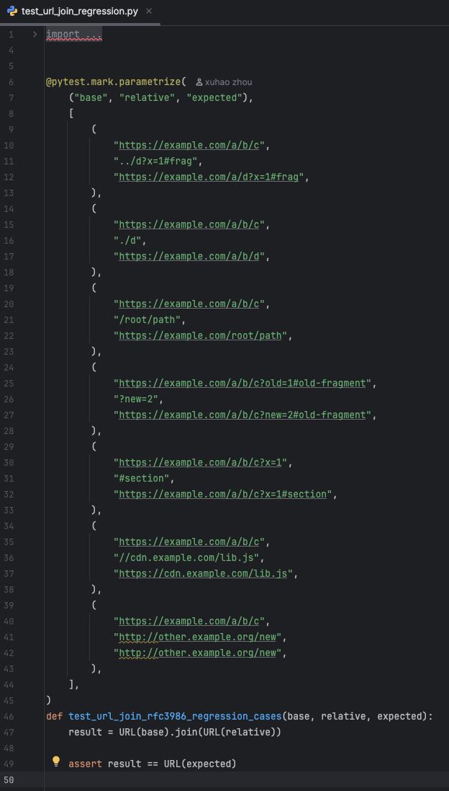
Figure 3 Focused regression tests for URL.join()
After adding the tests, the local regression suite passed. The number of passing tests increased from the baseline because the new focused tests were added. This provided a safer foundation for refactoring because any accidental behaviour change in the selected URL joining cases would be detected immediately.
  - Unit-Level Refactoring of URL.join()
The first implementation change was a unit-level refactoring of URL.join() in yarl/_url.py. The original method combined several different responsibilities in one place. It checked input type, handled scheme selection, handled network-path references, resolved relative paths, selected the correct query string, and selected the correct fragment. Although these operations are all part of URL joining, they are conceptually separate decisions.
The refactoring applied an Extract Method strategy. The path, query, and fragment resolution logic were separated into helper functions. This made the public URL.join() method shorter and easier to follow. After the refactoring, the main method retained the high-level control flow, while the detailed component-selection logic was delegated to smaller helper functions.
The extracted helper functions were:
- _resolve_join_path
- _resolve_join_query
- _resolve_join_fragment
This change did not alter the public API. The public method remained URL.join(), and callers continued to use the method in the same way. The purpose of the change was internal maintainability rather than external functionality.
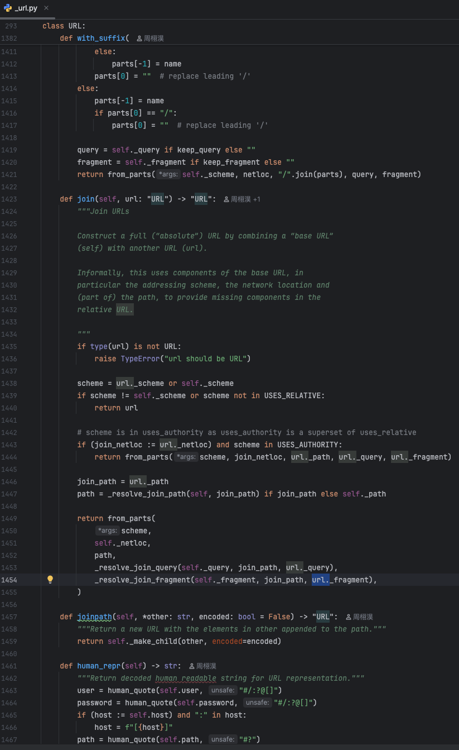
Figure 4 URL.join() after helper extraction
After this refactoring, the focused URL.join regression tests passed, the existing join-related tests passed, and the full local test suite passed. This provided evidence that the refactoring preserved behaviour.

  - System-Level Restructuring into yarl/_join.py
After the helper extraction, a second restructuring opportunity became visible. The helper functions were specific to URL joining, but they were still located inside yarl/_url.py, which was already the largest and most central module. To reduce the responsibility of _url.py, the join-specific helper functions were moved into a new private module:
yarl/_join.py
This was a small system-level restructuring. The purpose was not to create a new public feature, but to improve the internal organisation of the system. The new module contains private helper logic related to URL joining. The main URL class still remains in yarl/_url.py, and URL.join() still acts as the public entry point.
The new private module contains:
- _resolve_join_path
- _resolve_join_query
- _resolve_join_fragment
The _url.py module imports these helpers and uses them inside URL.join(). This reduces the amount of join-specific detail in the core URL module and makes the internal structure easier to understand. If future developers need to inspect or modify URL joining behaviour, the helper logic now has a more focused location.
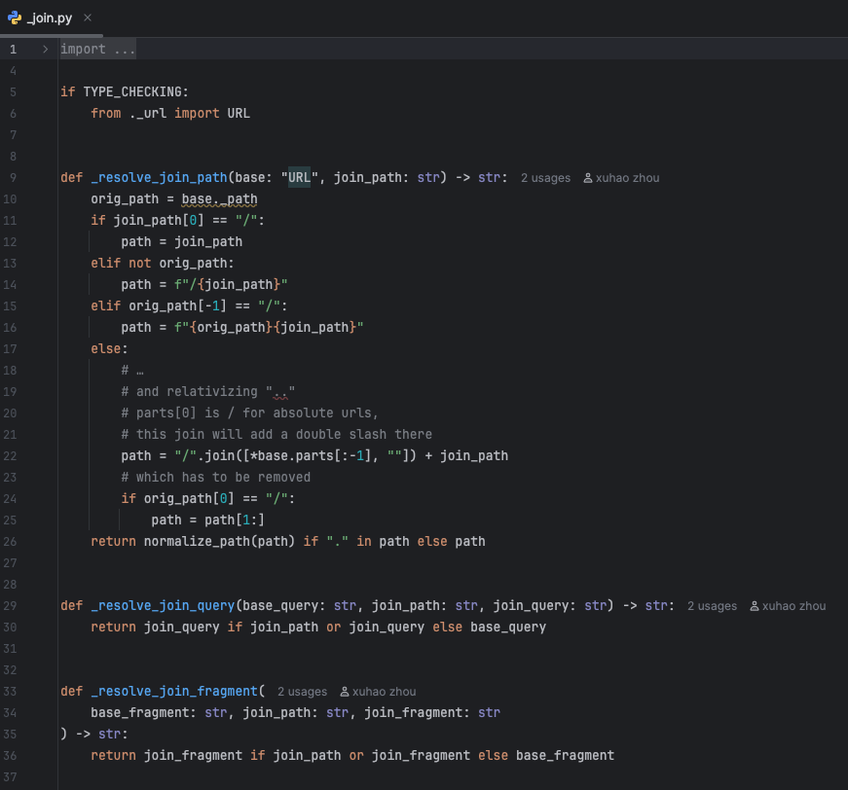
Figure 5 New private module for URL join helper logic
This restructuring is intentionally conservative. The new module is private, so it does not change the public API. The names of the helper functions are also private, indicated by the leading underscore. This is appropriate because they are implementation details rather than functions intended for library users.

  - Local Quality-Check Script
The original plan was to use GitHub Actions for automated regression testing. However, the course organisation reached its GitHub Actions quota, and remote workflows could not be triggered automatically. Following the course announcement, the project used local testing and committed the outputs as evidence.
To make local verification more repeatable, a local quality-check script was added:
tools/run_local_checks.py
The script runs the most important checks used during the reengineering process:
- focused URL.join regression tests
- existing join-related tests from tests/test_url.py
- the full pytest suite
- Radon cyclomatic complexity analysis
- Radon maintainability index analysis
The output files are written under Submission/final-check/. This gives the project a repeatable local alternative to remote CI. It also makes the evaluation process more transparent because the same checks can be rerun by group members.
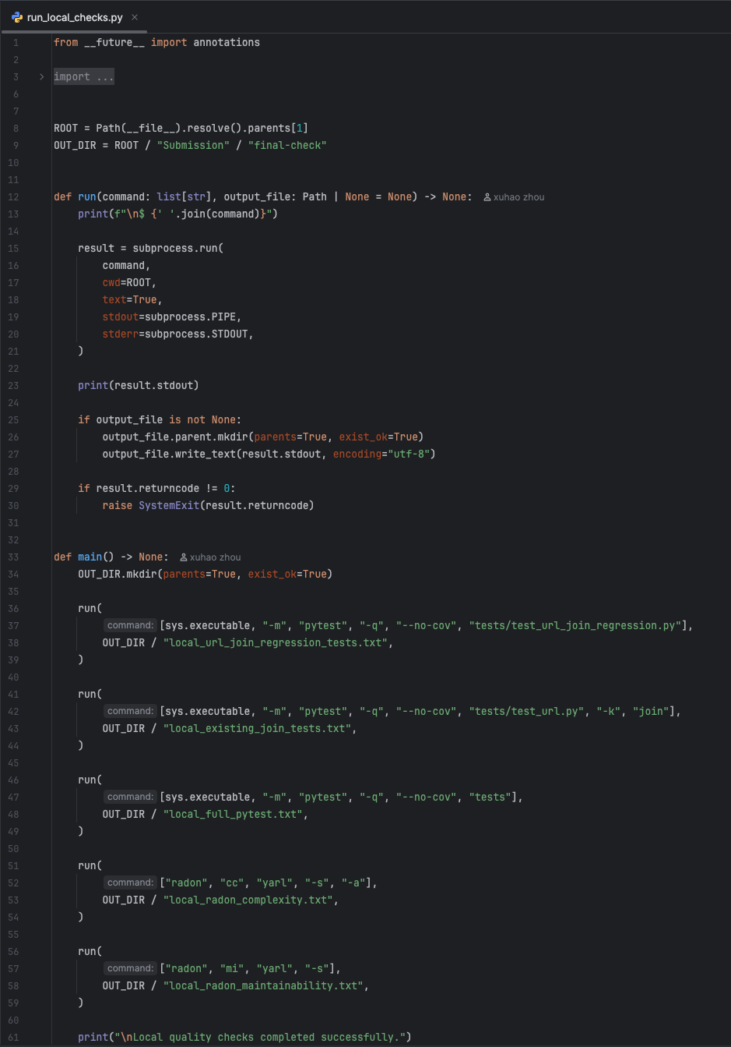
Figure 6 Local quality-check script used when GitHub Actions was unavailable
This script does not replace the value of remote CI entirely, but it reduces the risk caused by the quota limitation. It also supports the project’s evidence-based approach by making test and metric generation reproducible.

  - Before and After Evaluation
The restructuring was evaluated using regression testing and static analysis. The baseline local test result before reengineering was:
1115 passed, 103 skipped, 2 xfailed.
After adding focused regression tests and completing the refactoring and restructuring, the final local test result was:
1122 passed, 103 skipped, 2 xfailed.
The increase in passing tests is expected because seven focused regression tests were added for URL.join(). The important point is that the full test suite still passed after the code changes. This suggests that the restructuring preserved the existing behaviour covered by the test suite.
The complexity result also improved. Before refactoring, URL.join() had cyclomatic complexity C (17). After refactoring and restructuring, the final result was:
- URL.join: B (8)
- _resolve_join_path: B (6)
- _resolve_join_query: A (3)
- _resolve_join_fragment: A (3)

Table 3 Before and after complexity comparison
Component | Before | After | Interpretation
URL.join() | C (17) | B (8) | Main public method became simpler
_resolve_join_path | Not extracted | B (6) | Path-specific logic isolated
_resolve_join_query | Not extracted | A (3) | Query decision isolated
_resolve_join_fragment | Not extracted | A (3) | Fragment decision isolated

The result shows that complexity was not removed artificially by ignoring logic. Instead, the method was decomposed into smaller parts with clearer responsibilities. The public method now expresses the high-level URL joining process, while component-specific details are placed in private helper functions.
The maintainability improvement is therefore qualitative as well as quantitative. Quantitatively, the complexity of URL.join() was reduced from C (17) to B (8). Qualitatively, the code is easier to navigate because join-specific helper logic is now grouped in yarl/_join.py.
  - Risks and Limitations
The restructuring was deliberately limited in scope. Although the baseline analysis showed that URL.build() had higher complexity than URL.join(), it was not selected as the main target because it has a wider range of behaviours and would require more extensive regression testing. Attempting to refactor it within the available time could have increased the risk of accidental behavioural changes.
Another limitation is that the new tests cover representative URL.join() behaviours, but they cannot cover every possible URL edge case. URL handling is complex, especially when percent encoding, unusual schemes, authority components, path normalisation, and internationalised hostnames are involved. The existing test suite reduces this risk, but no test suite can prove complete correctness.
The GitHub Actions quota issue was also a limitation. Remote automated verification could not run, so all checks were performed locally. To address this, the group committed local test outputs and added the local quality-check script. This does not fully replace CI, but it provides repeatable evidence for the reengineering process.
Finally, the project focused on maintainability rather than performance. No performance benchmark was used to show whether the restructuring affected runtime. Since the change was mainly a decomposition of existing logic and the full regression suite passed, performance was not treated as the main evaluation criterion. With more time, a benchmark could be added to compare URL joining before and after the change.

  - Summary of Restructuring Work
The restructuring phase completed a controlled reengineering task around URL.join(). The work followed a regression-test-first approach. Focused tests were added before modifying the implementation. The method was then simplified through helper extraction, and the helper logic was moved into a new private module to improve modularity.
The final result preserved the public API and passed the full local regression suite. The complexity of URL.join() was reduced from C (17) to B (8), and the join-specific helper logic was separated into small private functions. The addition of a local quality-check script also improved the repeatability of verification under the course organisation’s GitHub Actions quota limitation.
Overall, this restructuring did not attempt to redesign the whole library. Instead, it demonstrated a focused and evidence-based reengineering process: identify a maintainability issue, protect behaviour with regression tests, apply a conservative refactoring, restructure internal helper logic, and evaluate the result using tests and static metrics.

- Conclusion

  - Project Accomplishment
This project completed a focused reengineering process for the aio-libs/yarl Python URL library. The group first imported a fixed upstream snapshot into the group repository and established a local working environment. Before making any changes, the original test suite was executed to establish a behavioural baseline. The baseline result was 1115 passed, 103 skipped, and 2 xfailed, showing that the selected snapshot was runnable and suitable for controlled reengineering.
The understanding phase combined several program comprehension techniques. Static analysis was used to collect LOC, cyclomatic complexity, and maintainability data. Repository history analysis was used to understand how the upstream project evolved over time. The group also examined the module structure, public API, and existing test distribution. This analysis showed that yarl/_url.py is the central and most complex module in the system, and that URL.join() was a suitable target for a focused restructuring task.
The restructuring phase followed a conservative and evidence-based approach. Instead of attempting a broad redesign, the group selected URL.join() because it had non-trivial complexity, was part of the public behaviour of the URL class, and could be protected with focused regression tests. Before refactoring, new tests were added to cover important URL joining behaviours, including relative paths, root-relative paths, query-only references, fragment-only references, network-path references, and absolute URL replacement.
The implementation was then improved in two stages. First, URL.join() was refactored by extracting path, query, and fragment resolution logic into helper functions. Second, these helper functions were moved into a new private module, yarl/_join.py, as a small system-level restructuring. This reduced the responsibility of yarl/_url.py while preserving the public API. The final local regression result was 1122 passed, 103 skipped, and 2 xfailed. The cyclomatic complexity of URL.join() was reduced from C (17) to B (8).

  - What Worked Well
The most successful part of the project was the use of evidence to guide the reengineering work. The group did not choose a target randomly. Instead, the target was selected based on baseline complexity results, module responsibility analysis, and upstream history. This made the restructuring decision easier to justify.
The regression-test-first approach also worked well. Adding focused tests before modifying the implementation reduced the risk of changing public behaviour. This was especially important because URL.join() is a public-facing method and URL joining has many edge cases. The existing test suite provided a broad safety net, while the new tests protected the selected behaviour more directly.
Another strength was the local quality-check script. Because GitHub Actions could not run automatically due to the course organisation reaching its quota, the group needed another repeatable verification method. The script made it easier to rerun focused tests, full tests, complexity analysis, and maintainability analysis locally. This helped preserve a clear evidence trail.

  - Limitations and Future Work
The main limitation of the project is that the restructuring scope was deliberately narrow. The baseline analysis showed that URL.build() had higher complexity than URL.join(), but it was not selected because it would have required a larger test design and carried greater behavioural risk. With more time, URL.build() would be a strong candidate for further investigation.
Another limitation is that the new regression tests cover representative URL joining behaviours but not every possible edge case. URL handling can involve unusual schemes, encoded characters, internationalised hostnames, authority components, and path normalisation cases. Future work could extend the regression tests using property-based testing or mutation testing to improve confidence.
Performance was also not the main focus of this project. The restructuring was intended to improve maintainability and modularity, not runtime speed. Future work could add benchmarks to confirm that the refactoring did not negatively affect URL joining performance.

  - Individual Reflections

Appendix A: Evidence Files
Baseline Evidence

Submission/baseline/baseline_pytest.txt
Baseline local pytest result before reengineering.

Submission/baseline/python_version.txt
Python version used for local testing.

Submission/baseline/pip_freeze.txt
Installed package versions in the local environment.

Submission/baseline/loc_by_file.csv
Baseline source and test LOC by file.

Submission/baseline/radon_complexity.txt
Baseline cyclomatic complexity report.

Submission/baseline/radon_maintainability.txt
Baseline maintainability index report.

Submission/baseline/coverage_baseline.txt
Baseline coverage output.

System Understanding Evidence

Submission/analysis/module_inventory.csv
Inventory of source modules, classes, functions, and imports.

Submission/analysis/test_inventory.csv
Inventory of test files and test function counts.

Submission/analysis/public_api.txt
Public API inventory for the yarl package.

Submission/analysis/current_system_understanding.md
Initial system understanding notes.

Submission/analysis/commits_by_month.csv
Commit activity grouped by month.

Submission/analysis/loc_over_time.csv
LOC growth across selected upstream revisions.

Submission/analysis/refactoring_commits.csv
Keyword-based search results for upstream refactoring-related commits.

Submission/analysis/evolution_summary.md
Summary of repository evolution analysis.

Submission/analysis/loc_over_time.png
Figure showing source, test, and total LOC growth over time.

Submission/analysis/commits_by_month.png
Figure showing upstream commit activity over time.

Reengineering Evidence

tests/test_url_join_regression.py
Focused regression tests for URL.join().

Submission/reengineering/pytest_after_url_join_tests.txt
Local test result after adding focused regression tests.

Submission/reengineering/pytest_after_url_join_refactor.txt
Local test result after the URL.join() refactoring.

Submission/reengineering/radon_complexity_after_url_join_refactor.txt
Complexity result after refactoring.

Submission/reengineering/radon_maintainability_after_url_join_refactor.txt
Maintainability result after refactoring.

Submission/reengineering/before_after_url_join_refactor.md
Before/after summary for the URL.join() refactoring.

Submission/reengineering/pytest_after_url_join_module_restructure.txt
Local test result after moving helper functions into yarl/_join.py.

Submission/reengineering/radon_complexity_after_url_join_module_restructure.txt
Complexity result after module restructuring.

Submission/reengineering/radon_maintainability_after_url_join_module_restructure.txt
Maintainability result after module restructuring.

Submission/reengineering/url_join_module_restructure_summary.md
Summary of the private module restructuring.

Final Verification Evidence

Submission/final-check/final_pytest_result.txt
Final local pytest result.

Submission/final-check/final_radon_complexity.txt
Final cyclomatic complexity report.

Submission/final-check/final_radon_maintainability.txt
Final maintainability report.

Submission/final-check/code_completion_summary.md
Summary of completed code work.
Submission/final-check/local_url_join_regression_tests.txt
Output from focused URL.join() regression tests run by the local quality-check script.

Submission/final-check/local_existing_join_tests.txt
Output from existing join-related tests.

Submission/final-check/local_full_pytest.txt
Output from the full local pytest suite.

Submission/final-check/local_radon_complexity.txt
Output from local Radon complexity analysis.

Submission/final-check/local_radon_maintainability.txt
Output from local Radon maintainability analysis.

